CS 210 Project Three- Corner Grocer Tracking Program Documentation
The purpose of this program is to analyze grocery purchase records and determine the frequency of items purchased throughout the day. The program reads data from the file CS210_Project_Three_Input_File.txt and stores the information in a map data structure. A map was selected because it efficiently associates each grocery item with its frequency count.
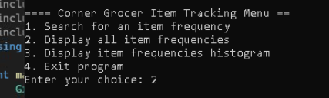
Figure 1. Main menu displayed when the program starts
The program was designed using a GroceryTracker class that contains private data members and public member functions. The class reads item data from the input file, stores item frequencies, creates a backup file named frequency.dat, displays all item frequencies, displays a histogram of items frequencies, and allows the user to search for the frequency of a specific item.
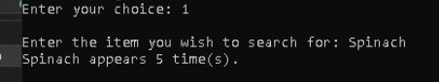
Figure 2. Searching for the purpose frequency of a specific item
When the program starts, it automatically loads the grocery data and creates the frequency.dat backup file. The menu provides four options. Option 1 allows the user to search for a specific item and view its purchase frequency. Option 2 displays all grocery items and their frequencies. Option 3 displays a histogram using asterisks to represent item frequencies visually. Option 4 exits the program.
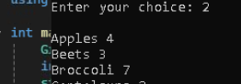
Figure 3. Display of all grocery items and their frequencies
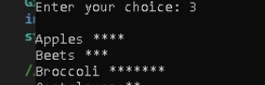
Figure 4. Histogram representation of item purchase frequencies.
This project demonstrates the use of classes, maps, file input/output, loops, functions, and user interaction. Inline comments and meaningful variable names were used to meet industry standards, improve readability, maintainability and reusability.

